**LAB 9 TASKS**

Roll no: 20k-0409 Name: Mukand Krishna

**TASK#1**

Fill up the Truth Table of Output

|  |  |  |  |  |  |  |  |  |  |  |  |  |  |
| --- | --- | --- | --- | --- | --- | --- | --- | --- | --- | --- | --- | --- | --- |
| ***E~*** | ***S2*** | ***S1*** | ***S0*** | ***I0*** | ***I1*** | ***I2*** | ***I3*** | ***I4*** | ***I5*** | ***I6*** | ***I7*** | ***Z*** | ***Z~*** |
| H | X | X | X | X | X | X | X | X | X | X | X | L | H |
| L | L | L | L | L | X | X | X | X | X | X | X | H | L |
| L | L | L | L | H | X | X | X | X | X | X | X | L | H |
| L | L | L | H | X | L | X | X | X | X | X | X | H | L |
| L | L | L | H | X | H | X | X | X | X | X | X | L | H |
| L | L | H | L | X | X | L | X | X | X | X | X | H | L |
| L | L | H | L | X | X | H | X | X | X | X | X | L | H |
| L | L | H | H | X | X | X | L | X | X | X | X | H | L |
| L | L | H | H | X | X | X | H | X | X | X | X | L | H |
| L | H | L | L | X | X | X | X | L | X | X | X | H | L |
| L | H | L | L | X | X | X | X | H | X | X | X | L | H |
| L | H | L | H | X | X | X | X | X | L | X | X | H | L |
| L | H | L | H | X | X | X | X | X | H | X | X | L | H |
| L | H | H | L | X | X | X | X | X | X | L | X | H | L |
| L | H | H | L | X | X | X | X | X | X | H | X | L | H |
| L | H | H | H | X | X | X | X | X | X | X | L | H | L |
| L | H | H | H | X | X | X | X | X | X | X | H | L | H |

**Task#2**

I) Design NAND gate using 2:1 MUX II) Design NOR gate using 2:1 MUX

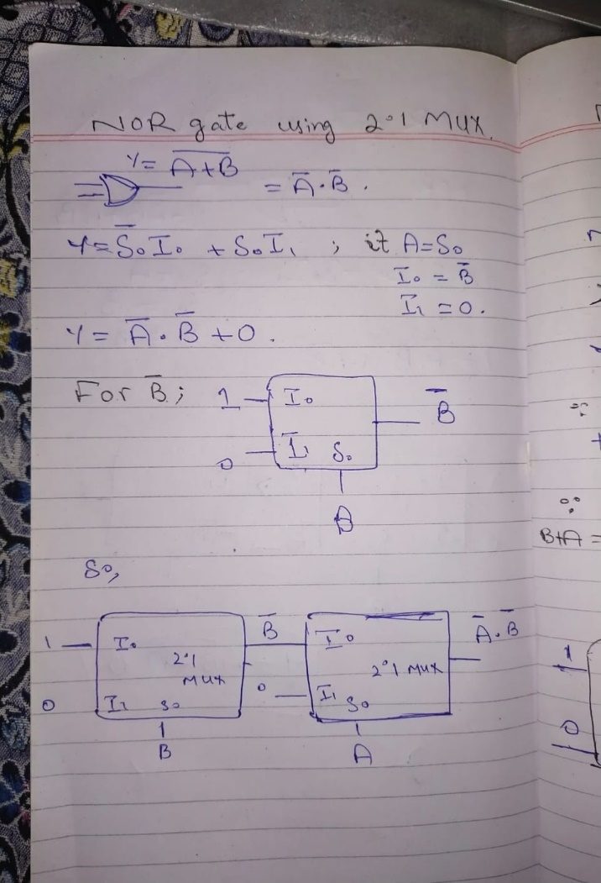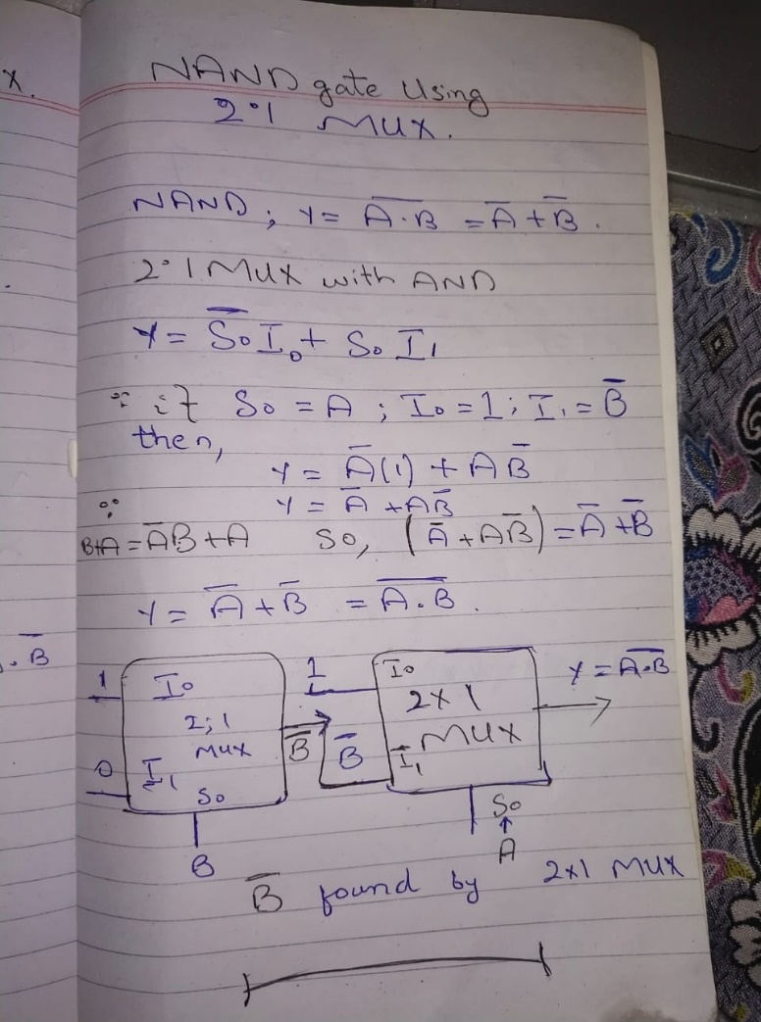

III) Design XOR gate using 2:1 MUX

